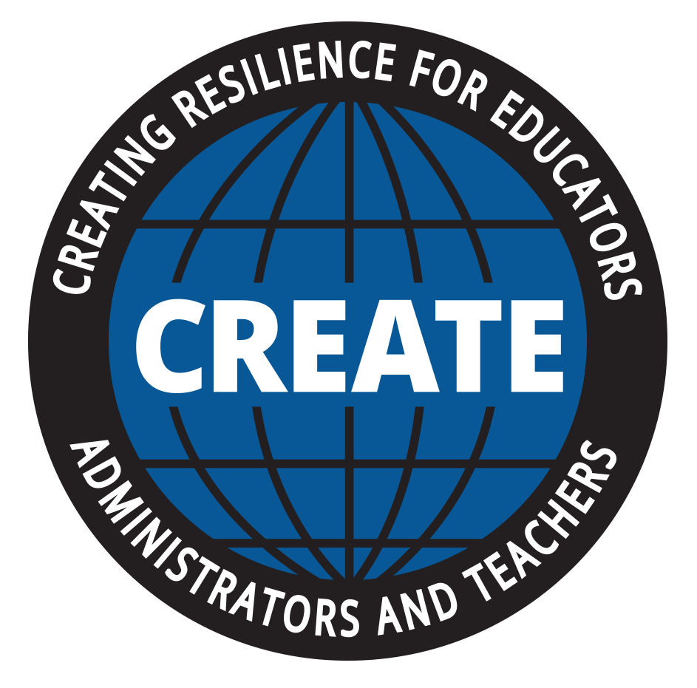 CARE

CARE (Cultivating Awareness and Resilience in Education) a Garrison Institute Program.

Presenter: Christa Turksma

Developing a practice to increase awareness and reduce stress:

- Three deep breaths
  - On your way to school
  - Short breaks during the day

- Set and intention for the day
- Create a visual reminder on your coffee mug, on the wall of your classroom, or on the refrigerator
- Choose an intention buddy with whom you will share your daily intentions and intention checks

- Mindfulness practice – start with 3-5 minutes
  - Sit with your feet flat on the floor, upright body posture, hands resting gently in your lap, eyes gazing downward or closed
  - Focus your attention on your breathing
  - Choose one physical sensation of breathing to focus on
    - The rising and falling of your chest
    - The sensation of breath as it passes through your nose
    - The in and out movement in the abdominal area
  - Distractions – when your mind wanders, as it will, bring your attention back to the breath and posture with gentleness, non-judgmentally

- Notice your emotions
- Notice your triggers
- Take deep breaths when you notice tension while in the classroom
  - Creates the space to respond rather than react

Contact Information
Christa Turksma: Co-Developer of the CARE program
christaturksma@gmail.com

